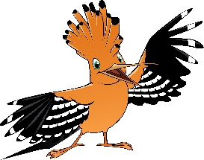

Dear Parents:
Send your kids on a roaring adventure!

At Roar VBS, kids discover that even though life gets wild, God is good. Roar is filled with incredible Bible-learning experiences kids see, hear, touch, and even taste! Sciency-Fun Gizmos™, team-building games, cool Bible songs, and tasty treats (including breakfast and lunch) are just a few of the standout activities that help faith flow into real life. Since everything is hands-on, kids might get a little messy. Be sure to send them in play clothes and safe shoes. Our outdoor activities will include water, so you might want to send a bathing suit and towel. Plus, we’ll help kids discover how to see evidence of God in everyday life—something we call God Sightings®. Get ready to hear that phrase a lot!

Your kids will also participate in a hands-on mission project, through a program called Operation Kid-to-Kid™. Kids at Roar VBS will have an opportunity to help Catholic Relief Services to Turn on the Water. All humans need clean water to stay healthy and live full lives. One way we can help people who need water is by raising money for organizations like Catholic Relief Services (CRS). CRS helps communities dig new wells and teaches them how to keep their water clean.

So, mark these dates on your calendar: June 10, 2019 to June 14, 2019. The fun starts at 8:30 a.m. for breakfast (activities start at 9:00 a.m.) and will end at 3 p.m. Call this number (321)632-6333 to register your children for this life-changing adventure!
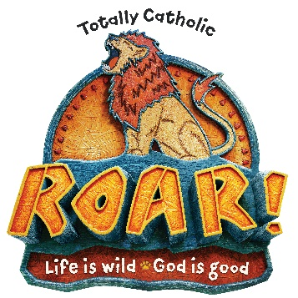
Sincerely,
Your Roar VBS Director
Darlene Wegner
dwegner@blessedsacramentcocoa.org

